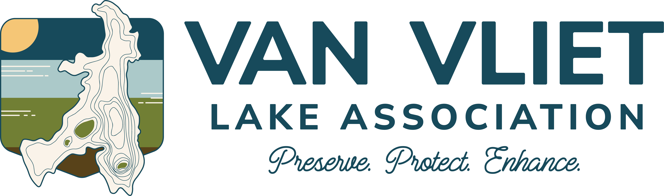
Van Vliet Lake Association Annual Meeting Agenda
July 19, 2025
- Welcome and Meeting Called to Order: 10:18 a.m.
Andy: greeting and call to order, introduction of president
Opening comments/history: R. Jacobsen gave historical info to Andy; he looked into history of the association and lake. Why is it named Van Vliet? 1960 changed the spelling to current spelling as it was originally “Van Vleete.” Until the late 1800s, all the lakes on the change were simply referred to as Presque Isle Lake. Vilas Co was not a county in 1848 when Wisconsin became a state. Counties were decided by population, and since the area was sparsely populated, it was not a county. Oneida county was first big county in our area, then that was split into Lincoln Co. Then in 1893 Vilas became a county. and Eagle River became County seat.

Our association’s first documentation was in 1960. That lasted for a bit but current bylaws formed in 2006 – present Bylaws on website.

Van Vliet is Dutch. There are a couple famous Van Vliets. There was a civil war general with this spelling. His son was in WWI but never lived in Wisconsin. No info as to who Van Vliet actually was. Andy wants to keep digging. Stay tuned.

- Approval of 2024 Annual Meeting Minutes
Jennifer read the minutes from the 2024 annual meeting, and the minutes were distributed to those in attendance.

Motion to approve minutes : Neil Brown
2nd: Lisa Cavannaugh

Open discussion: Bobbe Sisler: Merlin app; identifies birds

Motion carries.

- President’s Report
  - Membership Status: Van Vliet Lake Association (VVLA)
Please re-new memberships. Please sign in and add email so that all information is up to date.

68 members last year; 64 paid this year. To be a member, you must live within 1 mile of Van Vliet Lake. $15 dues for the year. The benefits of being a Lake Association member include benefits for a year which help achieve our mission: Preserve Protect Enhance our lake. Dues received in 2025 a bit lower but fewer people.

Last year: Tom Olson active in Last Wilderness Alliance (LWA). Tom asked member to help contribute to LWA to help fight wake surfing. There is now an ordinance against it on VVL, as well as most lakes in Vilas Co. Wake surfing is loading boat up with water and wake comes out the back and you can surf behind it without a rope. Wake goes to the bottom of the lake and as deep as 20’, This causes irreparable damage to lakes, particularly shallow lakes. Wake boats are not outlawed, but wake surfing is. There are a lot of lawsuits underway to take the bans down against wake surfing. People who own the boats are fighting the ordinances. Most recently, cases are in federal court.

- Treasure Report
Andy (Jeff unable to attend)

We contributed to the LWA.

See financials distributed at meeting: VVLA matched donations up to $500 to LWA. More than $500 from members; $650 from individual donations and VVLA matched $500 so in total $1150 given to LWA. Meets our mission to protect the lake.

We also donated to several other associations as seen on the financials, including hemlocks, discovery center

Big expense this year is graphic artist to do a logo ($350); on letterhead and website; branding the VVLA. Have not trademarked because of the additional expense.

Webiste consulting for fee from Scott at WebLifeWorks who also manages the The Discovery Center’s webpage.

Balances in VVLA accounts as of Monday, July 14.

  - ’24-‘25 News
    - Hazardous wake ordinance
    - PITLC (Presque Isle Township Lake Committee)

  - VVLA Social Activities
    - Winter Social & Pizza Party
    - Annual Independence Day Boat Parade
    - Fall Bonfire Idea

Bob Pottshast- chair: unable to attend but the social activities enhance our experience on the lake. Last year, the winter social was at PI Pub in February, well attended. The boat parade didn’t have great weather this year but plan to continue that event. Discussion about a fall social (bonfire), have also discussed ice fishing tournament. Diane Schroeder: commend Andy and Bob for the signs about activities. Signs only $7 apiece because we are recycling the metal stands

- Discussion and Thoughts from the Members attending

- Election of officers
  - Terms Expiring-Mark Osberg
  - Vice President – Brett Bussler
  - At large-Ed Brodsky
  - Open Seat

Terms expired for officers and board members: VP Ed Brosky’s term expired and Ed does not want to continue to be VP. He would like to be at-large member. Ed wants to assume Mark’s term. Brett Bussler will assume Ed as VP.

Treasurer expired but Jeff will stay.

One at large opening—if interested, it involves 2 meetings in year, zoom an option, and the annual meeting.

Motion to accept new officers (blanket motion): Motion by M. Jacobsen; 2nd by Jim Spreester. No opposed. Motion carries

Open discussion:
Novak island, there is a dead log, could injure someone

Neil Brown inquired about option to prevent or limit light pollution at night; neighbors keep light on and keeps from seeing stars. There is a town (PI) ordinance; contact constable; sent email to town supervisors (Mike Czarny). Best to contact Al Eschenbach, the town chair. Ronie: can have light when boating and need light at dock but then it should come off. Need to involve the constable.

Scott Cavannaugh: wake boarding is not the same as wake boating and that is ok. It’s like water skiing but on a snowboard.

Andy: At launch map, it shows no wake area around edge of our lake. New signage coming.

Lisa Cavannaugh: beavers causing damage on property; took out shore station tree; what can we do on the lake? Discussion had that the beaver can be trapped.

Depth: measure off of Jeff’s dock 2x/year; data will be on website

At large position: Lisa Cavanaugh nominates Scott Cavanaugh to the board; R. Jacobsen seconds; passes unanimously. Motion carries.

Tom Olson sent an email to Jennifer Brown and Andy Sisler. J. Brown read email. Tom would like to donate money to the VVLA and then have the VVLA donate the money to LWA to pay for legal services needed to fight the wake surfing litigation. Discussion had on this topic. R. Jacobson: opposed because if Tom wants to donate from LWA he can. R. Jacobsen states the position that it is not VVLA’s job to hire a law firm.
Andy noted that charitable accounts like Tom’s can only send to other qualified charitable organizations.

Consensus at meeting was that it is a dangerous precedent to send money through VVLA, particularly to pay atty fees. Not worth flushing it through us. Should we ever face an audit, we’d probably be ok because we took donation and made donation. Andy will speak to Tom about how this sets a dangerous precedent. No motion needed - Andy will respond back to Tom.

- Adjourn

Motion: Bobbe Sisler
2nd: Brett Bussler
Motion Carries

11:19 a.m.

- Guest Speaker, Ferdy Goode, Beaverbark Canoes

Known Andy Sisler for 10+ years; fly fisherman; makes models and full-size canoes; born in this area and has lived here for 75 years. “Dr. Kate baby.” Never owned a boat, canoes are his thing! What is “wilderness”? Can you drive up to it? If you want it, take a trip to Canada! He goes there with his birch bark canoes, which he has been building for years. Ferdy learned from a native Ojibwe birchbark builder. Ferdy noted that snowshoes also unique to N. America. Birchbark is 100% waterproof. Ferdy uses big knives, which he makes himself, to start splitting and smaller knives to do finer splitting. Once split out, he then uses “crooked knife” (mocotaugan) invented by native people in N. America. When carving, it is important to carve toward yourself. Ferdy makes all his tools for canoe building: an awl pokes holes in the birchbark, then he uses root from tree that he’s harvested and he sews the seams together. To date, Ferdy has made 82 canoes. Ferdy has a camp on E Birch Lake Road. It takes about 500 hours to make a canoe. Cuts have to be made on birchbark to make the canoe shape. Ferdy is also a teacher of how to make birchbark canoes. His biggest canoe is 22’ on display at Discovery Center in MW.

Paddles made from ash, birch, cedar, maple, cherry, spruce, popple, basswood. One piece.

No seats in his canoes. So must kneel or sit.

Rolls so it’s better in rougher water; not as stable as flat bottom canoes initially. Initially, likely to tip in when you get in!

Finish: 11:52 a.m.

- Potluck lunch

